5. Performing basic CRUD operation (create, update, delete) on db records.
CRUD Operations in SQL
CREATE TABLE users(
id INTEGER PRIMARY KEY,
name TEXT,
email TEXT
);
show tables;


CREATE (Insert a record)
INSERT INTO users(id,name,email)VALUES(1,'Akanksha','akanksha12@gmail.com');
select*from users;

select*from users WHERE id=1;
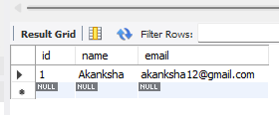
UPDATE (Modify existing record)
UPDATE users
SET name='Utkarsha',email='utkarsha04@gmail.com'
WHERE id=1;
select*from users;

DELETE (Remove a record)
DELETE FROM users WHERE id=1;
select*from users;


